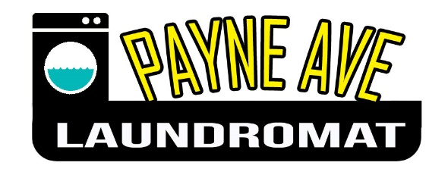
Cleaning Checklist

Job Description | Daily | Weekly | Monthly
Sweep Floor
Mop Floor
Empty Out Garbage Cans
Wash Down Machines
Clean out Lint Traps
Wash Windows
Vacuum
Wipe out Soap Trays
Dust
Clean Bathroom
Wash Folding Tables
Check Washers/Dryers for Debris
Use Broom to get cobwebs
Clean top of vending machines and front panels

